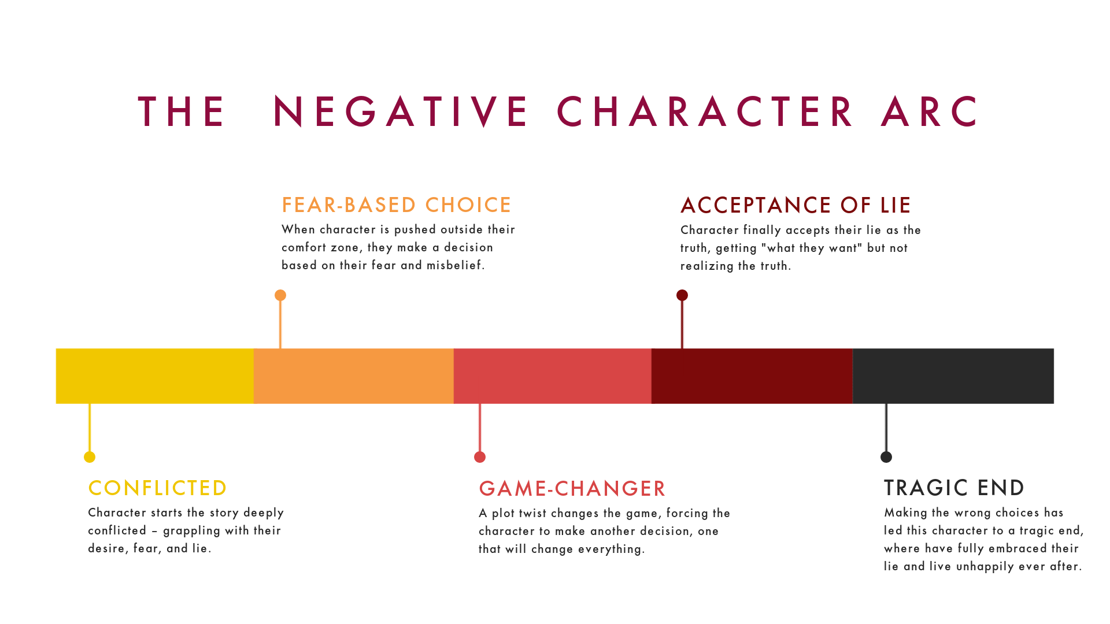

**1. The Conflicted Starting Point**

**Character starts the story deeply conflicted — grappling with their desire, fear, and lie.**

Ask yourself: What does my character think will bring them true happiness or contentment? How is their desire fundamentally based on their misbelief?

**2. First Fear-Based Choice**

**When character is pushed outside their comfort zone, they make a decision based on their fear and misbelief.**

Ask yourself: What is the “impossible choice”? Your character must be faced with options: stay inside their comfort zone and risk NEVER getting What They Desire, or venture into the unknown and accomplish their goal while STILL avoiding their fear.

**3. Game-Changing Midpoint**

**A plot twist changes the game, forcing the character to make another decision, one that will change everything.**

Ask yourself: What unexpected thing is going to upend my character’s plan (and entire life)? Why does it matter and how does it change the game?

**4. Acceptance of Lie**

**Character finally accepts their lie as the truth, getting “what they want” but not realizing the truth.**

Ask yourself: What makes my character embrace their lie, once and for all? What dramatic action do they take to get what they want?

**5. The Tragic End**

**Making the wrong choices has led this character to a tragic end, where they have fully embraced their lie and live unhappily ever after.**

Ask yourself: How have my characters’ bad decisions led them to their tragic end? How can I show my reader that *they* to blame for this whole mess?